Find My Doctor: Mobile application for Health Assistance
[IT 351]
A summer project report submitted in partial fulfillment of the requirements for the degree of Bachelor of Information Management awarded by Tribhuvan University.

Submitted by:
Utkarshika Baidya (T.U. Exam Roll No. 6050/14)
7-2-282-170-2014 (T.U. Registration No.)
St. Xavier’s College, Maitighar

A Summer Project Report Submitted to:
Faculty of Management, Tribhuvan University
In partial fulfillment of the requirements for the degree of

Bachelor of Information Management
Kathmandu
November 8, 2017


The undersigned certify that they have read and recommended to the Department of Computer Science for acceptance, a project report entitled “Find My Doctor” submitted by Utkarshika Baidya in partial fulfillment of the requirements for the degree of Bachelor of Information Management awarded by Tribhuvan University.

………………………………….
Mr. Bal Krishna Subedi
Supervisor /Lecturer
St. Xavier’s College

……………………………..
External Examiner
Tribhuvan University

……………………………..
Mr. Vishnu Kumar Rana
Head of Department
St. Xavier’s College

STUDENT DECLARATION

This is to certify that I have completed the Summer Project entitled “Find My Doctor: Mobile Application for Health Assistance” under the guidance of “Bal Krishna Subedi” in partial fulfillment of the requirements for the degree of Bachelor of Information Management at Faculty of Management, Tribhuvan University. This is my original work and I have not submitted it earlier elsewhere.

Date:November 8, 2017 Signature:
Name: Utkarshika Baidya

CERTIFICATE FROM THE SUPERVISOR

This is to certify that the summer project entitled “Find My Doctor:Mobile Application for Health Assistance” is an academic work done by “Utkarshika Baidya” submitted in the partial fulfillment of the requirements for the degree of Bachelor of Information Management at Faculty of Management, Tribhuvan University under my guidance and supervision. To the best of my knowledge, the information presented by him/her in the summer project report has not been submitted earlier.

Signature of the Supervisor

Name:Bal Krishna Subedi
Designation:Lecturer
Date:November 8,2017

ACKNOWLEDGEMENT

I would like to express my gratitude and appreciation to all those who immensely provided me with the guidance and the assistance to complete the project. I would like to extend my special gratitude to our Head of Department, Mr. Vishnu Kumar Rana, for his guidance and patience during this project and also for his mentoring throughout all the brief encounters with the research and development aspects of this project.

Furthermore, I would like to thank our project supervisor Bal Krishna Subedi, Lecturer, Department of Computer Science, St. Xavier’s College for providing me valuable guidelines, supervision and suggestions to successfully complete this project. The success and final outcome of this project required a lot of guidance and assistance from many people and I am very fortunate to have got this all along the completion of this project. I would like to express our sincere thanks to our teachers Mr. Jitendra Manandhar, Er. Rajan Karmacharya, Er. Sanjay Kumar Yadav, Er. Anil Kumar Sah, Mr.Samyam Maskey, Mr.Ramesh Shahi , Mr. Ganesh Yogi and Er. Saugat Sigdel Lecturers, Department of Computer Science, St. Xavier’s College, for guiding us in all possible ways to achieve our ultimate goal. Their inspiration and helpful guidance has made this project come to a success.

Similarly, I am appreciative to Mr. Om Nath Shrestha, Mr. Bibek Konda, Mr. Sagar Rijal, Mr. Manish Maharjan, Mr. Tej Bahadur Gurung and Lab Assistants, Department of Computer Science, St. Xavier’s College, for their support.

At the end, I would like to express my sincere thanks to my friend Sadichha Bhattarai and all others friends who helped me directly or indirectly during this project work.
Utkarshika Baidya (T.U. Exam Roll No.6050/14)

Executive Summary

Technology is one of the leading factors in the evolution of globalization. Human lives are being highly controlled by 0’s and 1’s. In information and communication technology, innovations have become smaller in size, more efficient and often more affordable. Mobile phones have played its role in enabling the mobility of businesses by its extension to entrepreneurship, banking, e-banking and health delivery system.
Whether it may be a first grade student or an elderly man in his seventies, everyone spends a certain part of the day with their mobile phone. As a gateway for communication, messaging, entertainment and information, mobile phones have become the expression of “digital age”.
Find My Doctor (FMD) is a service oriented platform that focuses on providing people to improve their health status by connecting to the doctors and hospitals easily. Lots of advancement has occurred in the medical field. The advancement has to be matched up. Application like these make peoples life easier and are beneficiary to every single person. Lives of people are invaluable; and providing them with a good health is a greater deed. So we can make the life of people easier by helping them find doctors at the right time so that lives can be saved.
The proposed system facilitates communication between patients, doctors and hospitals and integrates the information about doctors in different hospitals in the city. Public will be able to use the FMD as an application installed on their smartphones to help them find doctors with minimal effort and time.
Analyzing the current scenario, FMD aims to be a great benefit to every single person to be easily connected to the hospitals in the city. It also carries the potential to bring a breakthrough in the hospital service which ultimately is connected with human lives. Making impact on the community and digitizing a developing country like ours with the help of a field that no one stays away from helps the country to take a big leap in the use of IT in this technological era.

Keywords: Find My Doctor(FMD), digital age, application, Beneficiary.

TABLE OF CONTENT

Page
Title page of SP report i
Student Declaration ii
Certificate from the Supervisor iii
Acknowledgement iv
Executive Summary v
Table of content vi
List of Figure vii
List of Tables vii
Abbreviation viii

CHAPTER 1:INTRODUCTION 1
- Background 1
  - Problem Statement 2
  - Scope and Objectives 2
    - Objectives 2
    - Scope 2
  - Project Features 3
  - Requirement Analysis 3
    - Functional Requirements 3
    - Non- Functional Requirements 4
  - Feasibility Analysis 4
    - Technical Feasibility 4
    - Economic Feasibility 5
    - Legal Feasibility 5
    - Operational Feasibility 5
    - Schedule Feasibility 6
  - System Requirements 6
    - Developer Side 7
    - Client Side 7
    - Server Side 8
  - Literature Review 8
    - Research Work 9
      - Android, the world's most popular mobile platform 10
      - Android Based Service Process 10
CHAPTER 2: TASK AND ACTIVITIES PERFORMED 11
  - Project Management and Strategic tool……………………………………….......11
    - Android 12
    - JAVA 12
    - JSON 13
    - Fragment API 13
    - Firebase Cloud Computing 14
    - ClickChart…………………………………………………...……………..14
    - Microsoft Word 14
2.1.8 Android Studio Platform 15
  - Libraries Used 15
    - Volley Library 15
    - Secure Preferences 16
  - Project Work Flow and Schedule 16
  - Project Team 16
  - System Analysis 17
  - System Design 18
    - Flowchart 19
    - Context Diagram 20
    - Data Flow Diagram level 1 22
    - Dataflow Diagram level 2 23
    - Entity Relationship Diagram 24
    - Use Case Diagram 25
  - Project Schedule (Time Schedule, Gantt Chart) 27
  - Testing 29
    - Unit testing………………………………………………………………...29
    - Integration testing…………………………………………………………35
    - System testing……………………………………………………………..38
CHAPTER 3: DISCUSSION AND CONCLUSION………………………………. 39
3.1 Critical Analysis…………………………………………………………………….39
3.2 Limitations and Future Enhancement………………………………………………40
3.3 Conclusion…………………………………………………………………………..41
REFERENCES

LIST OF FIGURES
Figure 1 Android Based Service Process………………………………............................1
Figure 2 System Architecture…………………………………………………………….2
Figure 3 Flowchart……………………………………………………………………….2
Figure 4 Context Diagram……………………………………………………………….2
Figure 5 Data Flow Diagram Level 1……………………………………………………2
Figure 6 Data Flow Diagram Level 2……………………………………………………2
Figure 7 Entity Relationship Diagram……………………………………………………3
Figure 8 Use Case Diagram………………………………………………………………3
Figure 9 Gantt Chart…………………………………………………………………….3

LIST OF TABLES
Table 1 Software Development Requirements 7
Table 2 Client Software Requirement 7
Table 3 Server Software Requirement 8
Table 4 Gantt chart 9

LIST OF ABBREVIATION

ADT Android Development Tool
AES Advance Encryption Standard
AOS Android Operating System
API Application Program Interface
AVD Android Virtual Device
DFD Data Flow Diagram
ERD Entity Relationship Diagram
FAQ Frequently Asked Question
FCM Firebase Cloud Messaging
FMD Find My Doctor
GB Giga Byte
GCM Google Cloud Messaging
GPRS General Packet Radio Service
GPS Global Positioning System
ICT Information and Communication Technology
IDC International Data Corporation
IDE Integrated Development Environment
ITS Intelligent Transportation System
JDK Java Development Kit
JSON JavaScript Object Notation
OS Operating System
RAM Random Access Memory
SDK Software Development Kit
SMS Short Message Service

Chapter I: Introduction

1.Background
‘That service is the noblest which is rendered for its own sake’. — Mahatma Gandhi.
The human life on the earth is full of pleasures and sorrows, ups and downs, strength and weakness and health and illness, like day and night these happenings are inherent in everyone’s life cycle. But it is silver lining that there are noble people who work all their lives to mitigate the sufferings of the others. Among them, the profession of doctors is perhaps most respected for service to the society.
A doctor dedicates his life to the service of the patients. They relieve the sufferings and pain of mankind. They cure them from disease and illness. They strive to make the life of others better and healthier.
We find that the fields of medicine and surgery have advanced beyond imagination. A damaged organ can be transplanted, in today’s medically advanced world.
As a result doctors have been considered as “GOD” to people in their sufferings. And the place where they do the magic of providing longer lives are hospitals which have been an essential part of our lives providing medical facilities to people.
The numbers of people who visit hospitals these days are increasing in a high number and keeping track of all of the hospital activities and their records on paper is a time consuming task. There is no effective sharing mechanism of data among people and the data will not be properly backed up.
The FMD application in android will get the basic information about all details of particular doctors, information about diseases and will show the path or location of the particular hospital.
So this app will help get instant online appointments. We can use it anywhere at any time which shows the online registration form and user can get appointment.
Android is a software stack for mobile devices that includes an OS, middleware and key application. Android is a software platform and operating system for mobile devices based on the Linux operating system and developed by Google and the Open Handset Alliance. It allows developer to write manage code in a Java-like language that utilizes Google developed Java Libraries, but does programs developed in native code (Tzeng, 2015)

1.1 Problem Statement
When any user wants to know about the basic information of doctor, the person has to interact with net or any other consulted doctors or causality. If the person has further queries about this hospital they have to visit the hospital itself.
Person will have to call the hospital or wait in long lines for the appointments , user has to go directly to the hospital to fix the appointment .even if user enter in time he/she has to wait for appointment registration for a while which takes time.
All these factors are wastage of time for patients who are willing to cure their health in the first place. Waiting for appointments cause a lot of problem for patients. For the patients point of view finding the right doctor for the checkups and taking appointment waiting for hours in line which last for hardly 15 min is not appropriate.
Appointments may be cancelled due to various reasons but the patients may not be informed about it.
1.2 Objectives and scope
1.2.1 Objectives of the project:
- Scheduling the appointment of patient with doctors to make it convenient for both.
- Scheduling the services of specialized doctors and emergency properly so that facilities provided by hospital are utilized in effective and efficient manner.
- Information of patient history should be accessible to patients.
- Medicine prescription authorized by doctor should be available to patients anywhere and anytime.
1.2.2 Scope of this project:
- Reducing the wastage of time for patients from waiting for appointment.
- Reducing cost of management.
- Better communications among all the candidates involved with hospital
- Increase in efficiency of hospitals and thus can check up more number of patients
- Increase in rate of giving service and thus increase in profit.

1.3 Project Features
The project is based on addressing doctor’s related issues as quick as possible. This project consists of requests and databases of hospitals and doctors. The application has all relevant components of a good record processing system such as login interface, data access interface and requests interface. The application is based on android platform. Android devices are required to run this application. The data are all stored in the website database and can be accessed from any location. Use of mobile technology as an ICT tool is increasing day by day and huge potential is seen in hospital sector.

1.4 Requirement Analysis
Before the development of the system it was necessary to identify the requirements of the clients and the stakeholders. This process requires good amount of research and discussion with the people to find out the set of requirements. The method used for the requirements extraction in this project is a Qualitative research approach. It focuses more on the important parameters of the project. The research initiated focused more on the depth and relevance of the project’s parameter.
The requirements are distinguished into functional, non-functional and hardware/software requirements to make the development process efficient and organized so as to meet the predefined objectives of the project.

Functional Requirements

- The system should have user friendly User Interface.
- Should be able to add new post by new user.
- Should be able to access post of all users.
- Authentication of user before the use of the application
- Notification is send to the users who have installed this app.

Non- Functional Requirements

- System should not carry any ambiguity.
- System should run smoothly
- System should not crash
- System must work with existing resources and achieve the objectives

Feasibility Analysis
Feasibility analysis, in simple words is an analysis and evaluation of a proposed project to ensure if it is technically, economically and operationally feasible. (Sharma, 2011)As the name suggests, a feasibility analysis is a study of the viability of an idea. A feasibility analysis is a study made before committing to a project. A feasibility study leads to a concrete decision whether the proposed project is fit to be initiated and completed. Feasibility study considers various factors that are directly or indirectly concerned with the project. It focuses on answering the essential question of “should this proposed project idea proceed?” (Business Dictinonary, 2013)
Our feasibility study included following scope:

Technical Feasibility

Technical feasibility is based on an outline design of system requirements to determine whether the company has the technical expertise to handle completion of the project. It is an evaluation of the hardware and software and how it meets the need of the proposed system ( nbdc.unomaha.edu, 2014). The development of the system required the expertise in the android application development and the database concepts. The thorough understanding of the Android Software Development Kit like Android Studio was a must and could effectively address this with the adequate expertise in the mentioned platform. The current system developed is technically feasible. The android application is developed using Android Studio and for the firebase is used.

Economic Feasibility

The purpose of the economic feasibility assessment is to determine the positive economic benefits to the organization that the proposed system will provide (P.Beck, 2014). The system is economically feasible because the application developed under the system requires android mobile which is now easily available in the market and it is under the budget. Users can afford the smart mobiles which makes easier for them to use the application.

Legal Feasibility

The legal feasibility assessment determines whether the proposed system conflicts the legal requirements, e.g. a data processing system must comply with the local data protection regulations. This application will not violate any rules and regulations that might be applicable to it. And it regards of code, the system has been coded by me and only the open source has been integrated into my code.

Operational Feasibility

Operational feasibility is a measure of how well a proposed system solves the problems, and takes advantage of the opportunities identified during the definition and how it satisfies the requirements identified in the requirements analysis phase of the system development. To ensure success, desired operational outcomes must be imparted during the design and development (reference.business-finance, 2014). Feasibility of the project is analyzed in order to determine the effectiveness and efficiency of the system. The user interface designed for this system is user friendly. The results are displayed in the same user interface and can be easily understood by all the users. So, the project is operationally feasible.

Schedule Feasibility

A project will fail if it takes too long to be completed before it is useful. Typically, this means estimating how long the system will take to develop, and if it can be completed in a given time period using some methods like payback period. Schedule feasibility is a measure of how reasonable the project timetable is.
This project as well planned and could be completed in the schedule span of time. Time Schedule and Gantt chart helped to direct the work in proper way and thus the project could be completed meeting the defined objectives.

  - System Requirements
Find My Doctor comprises of a set of tools that help the users for ease access and use. The proper selection of the tools used was totally based on the structure and the functionality of the project. There are certain minimal requirements that must be fulfilled for smooth running of the applications. They are:

Developer Side

Operating System | Windows 7 or Above
Application System | Android Studio
Programming Language | Java android
Processor | Processor – Intel® Pentium (P) Dual CPU, 32 bit operating system
RAM | 2 GB minimum
Disk Space | 2 GB minimum
Internet Connection | At least 128kbps
Device | Smart phone with android OS version Ice Cream Sandwich or higher

Table 1 Software Development Requirements

Client Side

Operating System
Android version Ice Cream Sandwich and above
Table 2 Client Software Requirement

Server Side

Programming Language
Java

Table 3 Server Software Requirement

Literature Review

In healthcare, the distribution of smartphones and tablet PCs running operation systems like Apple iOS or Android, attracts the interest in many application fields. The development of applications for smartphones and tablet PCs running operation systems like Apple iOS or Google Android attracts the interest in many fields of daily living (Springer, 2011). The latest Smartphones made dramatic breakthroughs in processing power, higher random- access memory, and secondary storage along with the number of extra features like internet access have opened doors to a broad range of applications development.
An Android operating system (AOS) commonly used by Smartphone manufactures because it is an open source operating system based on the Linux kernel and designed primarily for touch screen mobile devices such as Smartphones and tablet computers. The android operating system (AOS) based electronic devices such as Smartphones and computer tablets are extensively used for many purposes like instant messaging, gaming, word processing, Internet and download number of applications online. A rapid growth of android phones has enabled to replace PC’s software and other licensed software development technologies. There are different kinds of healthcare applications developed in android Smartphones which help patients and their caregivers to reduce time and cost efficiency (M.W. Munir, 2015).
Life has been a rush for all in the living for earning process. It has been a hard time to help the people in need. Help in a sense of aids that can save someone’s life. In this busy state of one’s life our project has intended to flow the information to the public. An app in need is an app in deed.

Research Work

Android, the world's most popular mobile platform
Android powers hundreds of millions of mobile devices in more than 190 countries around the world. It's the largest installed base of any mobile platform and growing fast every day another million users power up their Android devices for the first time and start looking for apps, games, and other digital content (MAPS). Android gives you a world-class platform for creating apps and games for Android users everywhere, as well as an open marketplace for distributing to them instantly (Android, 2015).
There are different applications (apps) categories available for download from the online Google play store. Everyday thousands of new apps are uploaded in their online database. A number of applications related to healthcare are available in the medical category which is helpful in the diagnosis of vital sign parameters, vaccinations schedule, medicine reminder etc.

      - Android Based Server Process
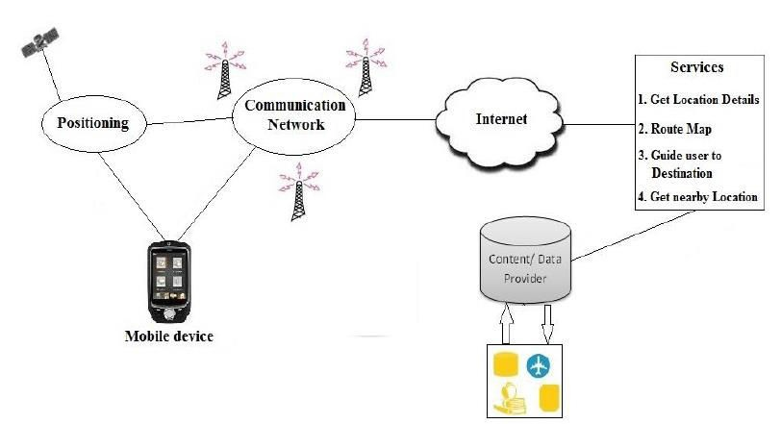

Fig 1:Android based server process
The diagram in figure 1: android based server process illustrates the android based services process. Here the service servers are responsible for processing service requests and sending back request results, and these service servers are maintained by service providers. Basically, these servers provide functionalities. Service providers usually do not store and maintain all the information requested by users. Instead, content providers are responsible for collecting and storing data and other related data. These data will be requested and processed by service servers and then returned to users (P.Doshi, 2014)
Considering those researches, we use the public API services in order to meet the objectives of the project. Android mobile phone cannot only receive the data collected by our hardware device but also can transmit these data to remote server in time . (Chung, 2011)This method not only simplifies the speed of the process of information acquisition processing and analysis, but also declines costs of equipment; therefore, researchers have become more interested in wireless health care (D.Modi, 2016)
Our solution is to build a system that will help the needful people or every person who wants knowledge or help in their precious time. Any information that is needed by a user can be supplied at the very time of installation of the app (sometimes after registration). This makes the availability of a technician to install software not necessary and with such heavy databases it is a quick implementation of a notification of doctors in the hospitals.

CHAPTER 2:TASK AND ACTIVITIES PERFORMED

Project Management Strategy and Tools

A project is a temporary activity designed to produce a unique product, service or result. Project management is the application of knowledge, skills and techniques to execute projects effectively and efficiently. The constraints for this project, as for most projects, have been time, cost and quality. Project management is necessary to complete the project under these constraints and utilize the resources properly (Cloud based Platform, 2014).
Project management can be defined as the process of applying knowledge, skills, tools as well as techniques to project activities to meet the project requirements. According to Project Management Institute's "A Guide to the Project Management Body of Knowledge", project management processes can be categorized into five groups- initiating, planning, executing, monitoring and controlling and closing (Project management Institute).
The overall development of the system was carefully analyzed under the proper guidance from the supervisor and team member to make the project a grand success.

Objectives of projects management are:
    - Understanding the importance of linking the information system to business needs.
    - Being able to create a system request.
    - Ability to perform a feasibility analysis.
    - Understand how projects are selected in some organization .

In order to achieve these objectives, it is very much necessary to use modern tools. The proposed tools to be used in this project are:

Android

Android is a new, next-gen mobile operating system that runs on the Linux Kernel. Android Mobile Application Development is based on Java language codes, as it allows developers to write codes in the Java language. These codes can control mobile devices via Google-enabled Java libraries. It is an important platform to develop mobile applications using the software stack provided in the Google Android SDK (openhandsetalliance) Android mobile OS provides a flexible environment for Android Mobile Application Development as the developers can not only make use of Android Java Libraries but it is also possible to use normal Java IDEs. Android Mobile Application Development can be used to create innovative and dynamic third-party applications. (Katti, 2012)

JAVA

I developed android applications using the Java programming language. As Java is a very popular programming language developed by Sun Microsystems developed after C and C++. Java programming languages are only as powerful as their libraries. These libraries exist to help developers to build application.
Some of the features are:
      - Easy to learn and understand
      - Designed to be platform-independent and secure, using virtual machines
      - Object-oriented programming language

Android relies heavily on these Java fundamentals. The Android SDK includes many standard Java libraries as well as special Android libraries that will help us to develop awesome Android applications. (tutsplus, 2011)

JSON

JSON is used in the project as it is easy for machines to parse and generate. JSON format is syntactically identical to the code for creating JavaScript objects. JSON stands for JavaScript Object Notation. It is an independent data exchange format and is the best alternative for XML. We can parse the JSON file and extract necessary information from it. Android provides four different classes to manipulate JSON data. These classes are JSONArray, JSONObject, JSONStringer (tutorialspoint).

JSON is built on two structures:
    - Collection of name/value pairs. In various languages, this is realized as object, record, structure, dictionary, hash table, keyed list, or associative array.
    - An ordered list of values. In most languages this is realized as an array, vector, list or sequence.

Fragment API

A Fragment represents a behavior or a portion of user interface in an Activity. You can combine multiple fragments in a single activity to build a multi-plane UI and reuse a fragment in multiple activities. You can think of a fragment as a modular section of an activity, which has its own lifecycle, receives its own input events and which you can add or remove while the activity is running (Fragment API)

Firebase Cloud Computing

Firebase Cloud Messaging (FCM) provides cross-platform for messaging and let us reliably delivers messages and notifications.
For the push notification, Firebase Cloud Messaging is used. Firebase Cloud Messaging (FCM) is the new version of Google Cloud Messaging (GCM) under the Firebase brand. It inherits GCM’s core infrastructure with additional features such as simplified client development and new server less notifications solution with a web console.

FCM provides an option for developers and organizations seeking a flexible notification platform that requires minimal coding effort to get started, and a graphical console for sending messages or notifications in an application or device (cloud messaging).

Click Charts

Click Charts is used in project to design flowchart, DFD, Entity Relationship Diagram Sequence diagram, Use Case diagram and schema diagram. Click Charts easily create a visual representation of a process, organization, mind map or other diagram.

Various features of Click Charts are:
      - Visualize complex processes and organizations
      - Create value stream and data flow diagrams
      - Identify bottlenecks and process optimization opportunities

Microsoft Word

Microsoft Word 2010 is a word-processing program that has been designed to help one create a professional-quality documents. It helps in organizing and writing the documents more efficiently. (support.office, 2016).PCMag has rated it 4.5/5 as every imaginable formatting and convenience feature for creating a document is added and is considers as a world-wide standard for text documents. However, few features are still confusing to use . Similarly, TechRadar has also rated it 4.5/5 as it has clean design and all the necessary features (Mendelson, 2016).

Android Studio Platform

Android Studio is Google’s official IDE that has many features such as:
      - Create, delete and view Android Virtual Devices (AVDs).
      - Create and update Android projects.
      - Flexible gradle based build system.
      - Code templates to help build common app features

Libraries Used

Volley Library

Android volley is a networking library that makes networking calls much easier, faster without writing tons of code. By default, all the volley network calls work asynchronously, so we don’t have to worry about using AsyncTask anymore. (androidhive, 2014)Volley comes with lots of features. Some of the
      - Request queuing and prioritization
      - Effective request cache and memory management
      - Extensibility and customization of the library to our needs
      - Cancelling the requests

Volley library is used in our project to send and receive data from webserver as it is much faster and caches everything to avoid downsides of AsyncTask class.

Secure Preferences

For session management, login details are saved in the Shared Preferences. Shared Preferences are used to store relatively small collection of key values. Shared Preferences values will persist across user sessions, even if the user closes the application. But since the values in the shared preferences are stored in a simple XML file in the user’s device, it can be read and modified on a rooted android device. So, a library called Secure Preferences was used to encrypt information before saving it in the Shared Preferences. It uses AES 128-bit encryption to encrypt the values (Android).

Project Work Flow and Schedule
- Team Size: 1
- Total Effective Project Duration: 12 Weeks

Project Team

Resource | Role
Mr.Bal Krishna Subedi | Supervisor
Ms.Utkarshika Baidya | Developer/Designer
Table 4: Team resources and roles

Project issues must be identified, managed and resolved throughout the project in order for the project to be successful. Issue resolution plays an important role in maintaining project stability and efficiency throughout the project lifecycle. It addresses obstacles that can hinder project success and/or block the project team from achieving its goals.

Responsibilities of Supervisor:
- Schedule the project
- Schedule Tracking
- Share information

Responsibilities of developer/designer:
- Research about the project
- Analyze and design
- Development and testing
- System Installation and Implementation
- Project Documentation and Report Submission

System Analysis

Systems analysis is a process of collecting factual data, understand the processes involved, identifying problems and recommending feasible suggestions for improving the system functioning. System Analysis includes subdividing of complex process involving the entire system, identification of data store and manual processes. The major objectives of systems analysis are to find answers for each business process: What is being done, how is it being done, who is doing it, when is he doing it, why is it being done and how can it be improved.
System analysis is a detailed study of various operations performed by a system. It is a process of collecting and analyzing facts with respect to the existing system operation of the situation prevailing so that an effective computerized system may be designed and implemented if proved feasible.
That is a structural process related to four significant phases. They are study phase, design phase, development phase and implementation phase. A good analysis is essential for the development of a new improved system .

System Design

The design of the application addresses the requirements set in the initial stage of the application development. Various diagrams such as system architecture, data flow diagrams, use case diagram, sequence diagram, Entity Relationship diagram and system flowchart were created in the design phase to make the development process much easier. The graphical representation of the project makes us able to have the overview of the system and its various structural and functional aspects. The development phase is hugely assisted by the design of various components. The design part however excludes any association with the code that builds the application.

2.6.1 Flowchart

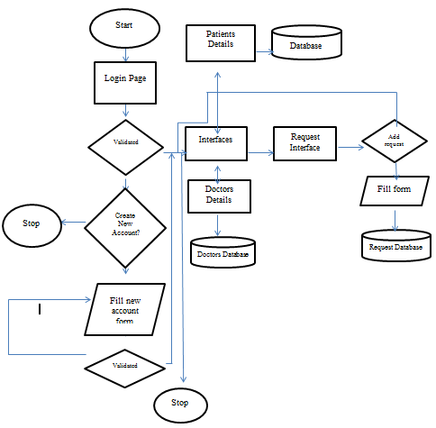

Fig : flowchart

The diagram in figure 2. Flowchart illustrates the work flow of the web based application. System flowchart is the graphical representation of the flow of data in the system and represents the processes of the system. (Merriam)Before accessing any feature of the application, the user must first create an account and give user information. If the user already has an account, then they can just login using login information. Once logged in, the user is authorized to view public posts, make a new post, view the map, update user account and configure settings. Users can then logout and exit any time they choose.

2.6.2 Context Diagram

The diagram in figure represents a graphic design that clarifies the interfaces and boundaries of the project. A DFD Level 0 in software engineering and system engineering is a diagram that defines the process that involves in the web application. This diagram is a high-level view of a system.

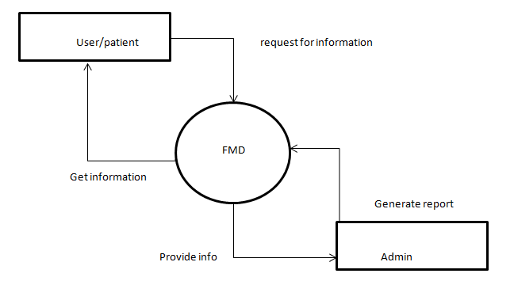

Fig 3: Data flow Diagram(level 0)

The diagram in figure 3.data flow diagram (level 0) explains the boundary between the system, or part of the system with its environment, showing the entities that interact with it (Sybase). The two types of building blocks used in the above figure are the system (represented by the central circle) and the remaining entities that interact with the system. The Mobile application is the core system and the user/patient, admin and the system database are the entities. Relationships are the labeled lines that describe the basic interaction between the entities and the system.

6.2.3 Data Flow Diagram level 1

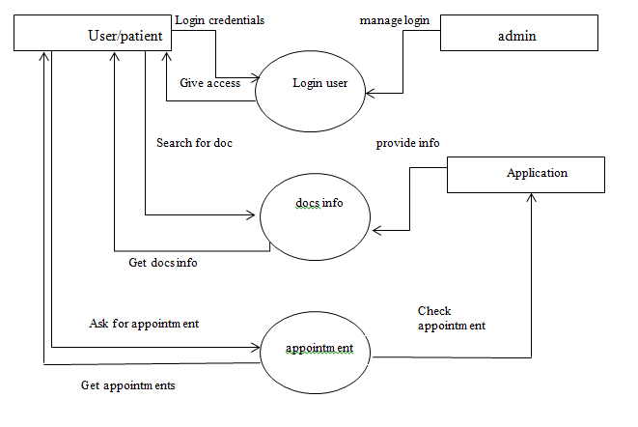
Fig 4:DFD level 1

The diagram in figure 4: is the 1st level DFD for the mobile web application system. It consists of 3 processes: Login, Doctors Info, and Appointment Request. The dataflow diagram shows the linear flow of data from these processes to one another. First the user is authorized by login or registration then they can access other processes such as view map, view doctor’s info and get appointments.

Dataflow Diagram level 2

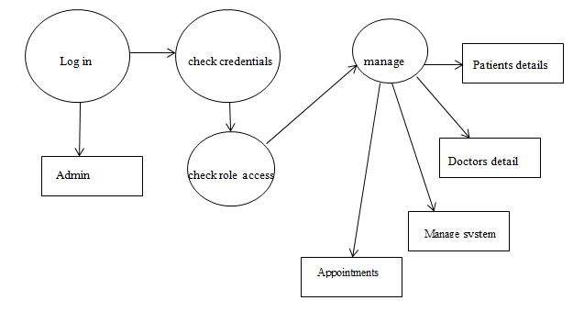
Fig 5:DFD level 2
The diagram in figure 5: DFD level 2 is the second level dataflow diagram for the login activity. An admin has the access to all the above modules in order to manage and smoothly run the application. It shows the details about the login activity. After logging in what other features and details are available is shown in the 2nd level of data flow diagram. It checks or manages the different feature like patient details, doctors details, management of the system and management of the appoinments.

    - Entity Relationship Diagram
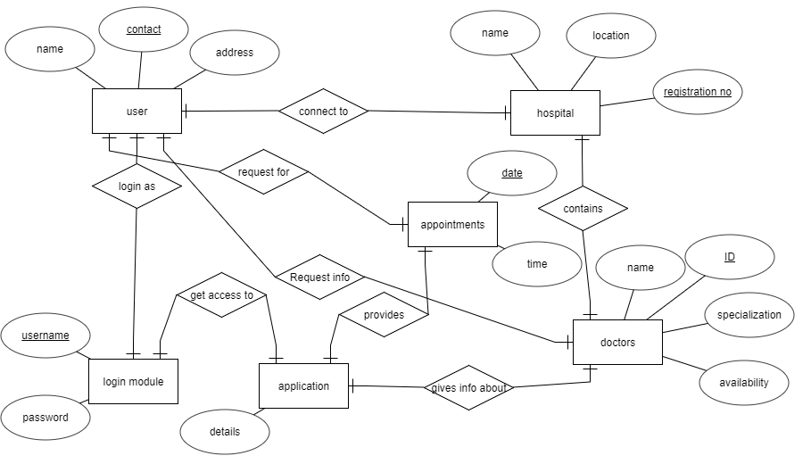
Fig 6: ER diagram

The diagram in figure 6: Entity Relationship diagram for the mobile web application. An entity-relationship diagram (ERD) is a data modeling technique that graphically illustrates an information system's entities and the relationships

between those entities. Here, in this diagram there are total six entities user, hospital , login module, appointment, application, doctors and eight relationships connect to, login as, request for, request info, get access to, give info about, provide and contains. Each of the entities have some attributes, here doctors entity have its four attributes Id, specialization, availability and name. Similarly, other entities have their own attributes and so on.

Use Case Diagram

Use Case Diagram is a diagrammatic representation that helps to represent the interaction of the user with system. The use case diagram consists of use cases and actors and shows the interaction between them. The important features of use case diagram can be defined as follows:

- to show the interaction between the use cases and the actor
- to represent the system requirement from user’s perspective
- the use cases are the functions that are to be performed in the module
- an actor could be the end-user of the system or an external system .

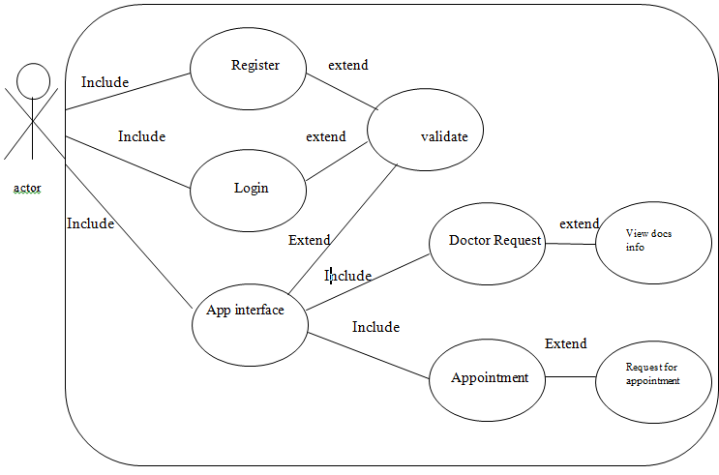
admin
Include

Fig 7:UseCase Diagram

The diagram in figure 7: Use Case Diagram of the system. It has two actors: the user and admin and use cases: register, login, ,validate, application interface, doctors request, appointment request. The use cases have relationships like include and extend. For example, the relationship between the doctors request use case and view doctor use case is that of extend. This is because the user may or may not choose to search doctor. On the other hand, the relationship between the login use case and validate user use case is that of include as the user must always go through the phase of validation.

Time schedule and gantt chart

Task Name | Start Date | End Date | Duration
Idea and Concept | 06/01/17 | 06/03/17 | 3d
Project Topic Selection and analysis | 06/06/17 | 06/06/17 | 1d
Research and Paper study | 06/07/17 | 06/10/17 | 4d
Feasibility Study | 06/12/17 | 06/13/17 | 2d
Background Study | 06/14/17 | 06/14/17 | 1d
Requirement Study | 06/15/17 | 06/17/17 | 3d
Preliminary Research on the project | 06/19/17 | 06/20/17 | 2d
Preparing Project Proposal | 06/19/17 | 06/21/17 | 3d
Collecting and producing initial list of references of the project | 06/20/17 | 06/20/17 | 1d
Proposal Submission | 06/22/17 | 06/22/17 | 1d
Initial review | 06/23/17 | 06/24/17 | 2d
Research on Volunteering organization | 06/22/17 | 06/30/17 | 7d
Meeting the Supervisor | 06/30/17 | 06/30/17 | 1d
Data Flow Diagram | 06/30/17 | 07/05/17 | 4d
Other Design Diagrams | 06/05/17 | 07/10/17 | 4d
Group Discussion | 06/11/17 | 07/11/17 | 1d
Review of Project | 07/13/17 | 07/13/17 | 1d
Coding and Unit Testing | 07/16/17 | 08/17/17 | 24d
Review with supervisor | 08/02/17 | 08/02/17 | 1d
System and Integration Testing | 08/11/17 | 08/15/17 | 3d
Group Discussion | 08/15/17 | 08/15/17 | 1d
Report Writing | 06/23/17 | 08/22/17 | 43d
Draft report writing | 08/23/17 | 08/23/17 | 1d
Proof reading | 08/24/17 | 08/24/17 | 1d
Draft submission to supervisor | 08/25/17 | 08/25/17 | 1d
Corrections for Final Draft | 08/28/17 | 08/28/17 | 1d
Final Documentation Printing and Binding | 08/30/17 | 09/01/17 | 3d
Final report submission to college | 09/16/17 | 09/17/17 | 1d
Table 4: Time Schedule

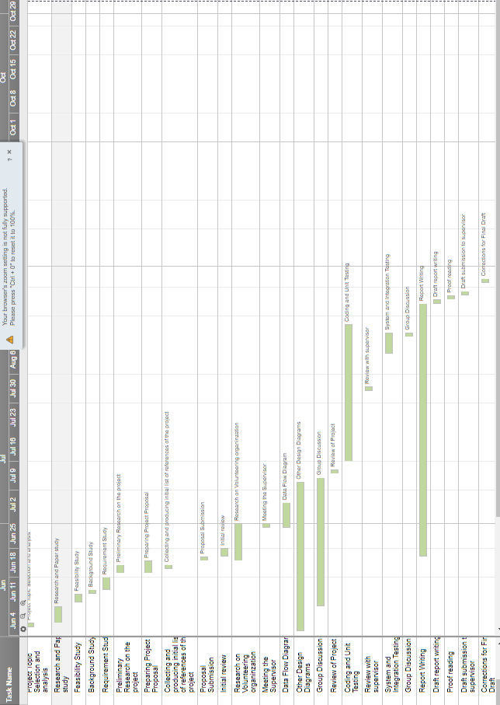
Fig: Gantt Chart

  - Testing
Testing is evaluation of the software against requirements gathered from users and system specifications. Software system testing identifies important defects, flaws, or errors in the application code that must be fixed. Testing is conducted at the phase level in software development life cycle or at module level in program code. Software testing comprises of Validation and Verification. Testing is executing a system in order to identify any gaps, errors, or missing requirements in contrary to the actual requirements.
During the designing process, this project had so many bugs which were debugged one by one analysing the problem occurred on each step. This project has gone through following testing procedure.

2.8.1 Unit Testing

This type of testing is performed by developers before the setup is handed over to the testing team to formally execute the test cases. Unit testing is performed by the respective developers on the individual units of source code assigned areas. The developers use test data that is different from the test data of the quality assurance team. The goal of unit testing is to isolate each part of the program and show that individual parts are correct in terms of requirements and functionality.
1. Unit testing
Test case 1: Welcome
Test Data: Empty form data
Expected Outcome: User login is prevented if the user is not registered.

Evidence:
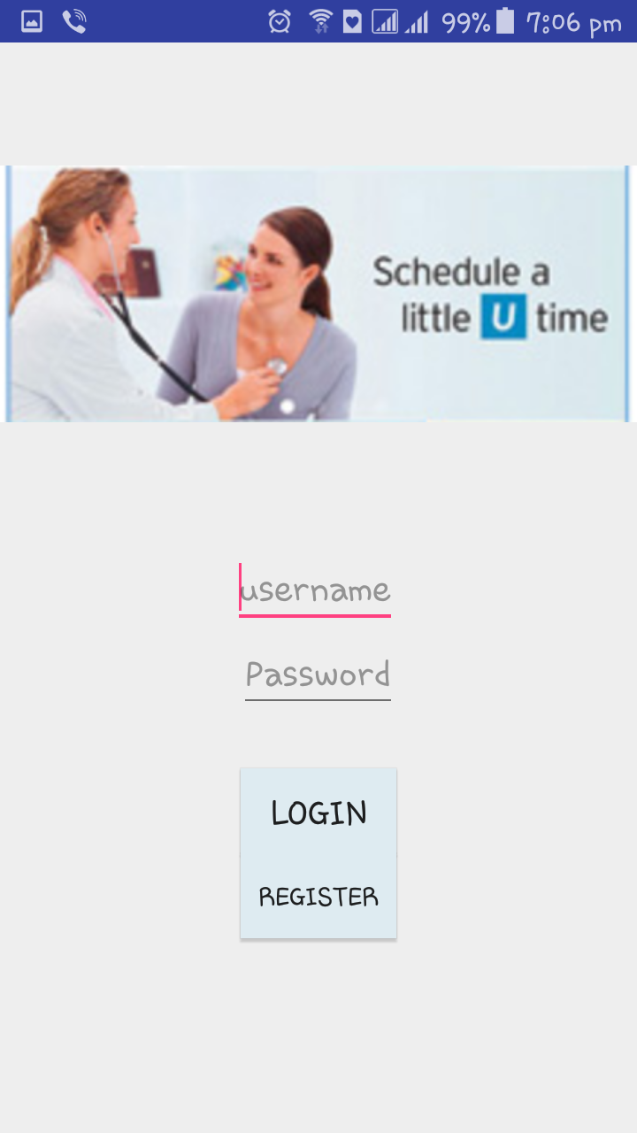

Code:
public class Login extends AppCompatActivity {
EditText Username, Password;
Button Login, SignUp;
FirebaseAuth firebaseAuth;
@Override
public void onCreate(Bundle savedInstanceState) {
super.onCreate(savedInstanceState);
setContentView(R.layout.login);
SharedPreferences sharedPreferences = getSharedPreferences("loginstate", MODE_PRIVATE);
Boolean condition = sharedPreferences.getBoolean("loggedin", false);
if (condition) {
Intent intent = new Intent(Login.this, MainActivity.class);
startActivity(intent);
}
firebaseAuth = FirebaseAuth.getInstance();
Username = (EditText) findViewById(R.id.user);
Password = (EditText) findViewById(R.id.pass1);
Login = (Button) findViewById(R.id.plogin);
SignUp = (Button) findViewById(R.id.register);
Login.setOnClickListener(new View.OnClickListener() {
@Override
public void onClick(View v) {
final String user = Username.getText().toString();
final String pass = Password.getText().toString();
firebaseAuth.signInWithEmailAndPassword(user, pass).addOnCompleteListener(Login.this, new OnCompleteListener<AuthResult>() {
@Override
public void onComplete(@NonNull Task<AuthResult> task) {
Intent intent = new Intent(getApplicationContext(), MainActivity.class);
startActivity(intent);
SharedPreferences preferences = getSharedPreferences("myfile", MODE_PRIVATE);
String x = preferences.getString("username", null);
String y = preferences.getString("password", null);
if (user.equals(x) && pass.equals(y)) {
SharedPreferences p = getSharedPreferences("loginstate", MODE_PRIVATE);
Toast.makeText(Login.this, "logged in", Toast.LENGTH_SHORT).show();
Intent intent1 = new Intent(Login.this, MainActivity.class);
startActivity(intent1);
SharedPreferences.Editor editor = p.edit();
editor.putBoolean("loggedin", true);
editor.commit();
} else {
Toast.makeText(Login.this, "username and password doent match", Toast.LENGTH_LONG).show();
}
}
});
}
});
SignUp.setOnClickListener(new View.OnClickListener() {
@Override
public void onClick(View v) {
Intent intent = new Intent(Login.this, Registration.class);
Test case 2: Registration
Test Data: register the data
Expected Outcome: User login is prevented if the user is not registered.registration is done.
Evidence:

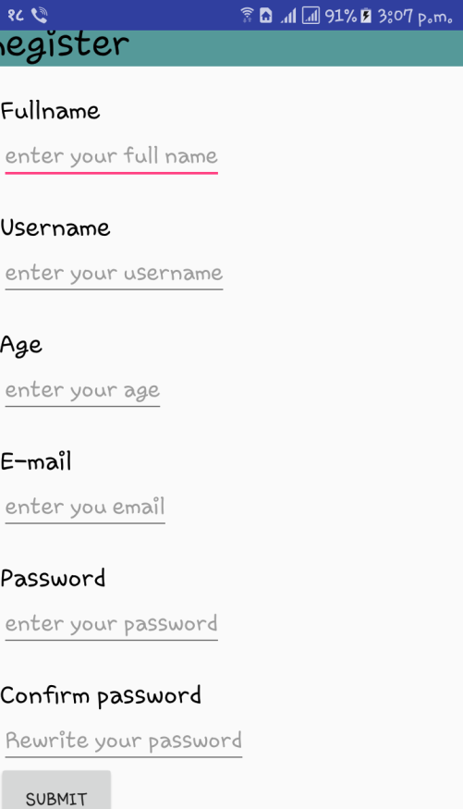

Code:
package com.example.utkarshika.FindMyDoctor;
public class Registration extends AppCompatActivity {
EditText username, password,fullname,age,email,confirm;
Button sub, clear;
//RadioButton m, f;
FirebaseAuth auth;
@Override
public void onCreate(Bundle savedInstanceState) {
super.onCreate(savedInstanceState);
setContentView(R.layout.register);
auth = FirebaseAuth.getInstance();
fullname= (EditText) findViewById(R.id.fname);
username = (EditText) findViewById(R.id.uname);
age= (EditText) findViewById(R.id.Age);
email= (EditText) findViewById(R.id.email);
password = (EditText) findViewById(R.id.pass);
confirm= (EditText) findViewById(R.id.cpass);
sub = (Button) findViewById(R.id.submit);
sub.setOnClickListener(new View.OnClickListener() {
@Override
public void onClick(View v) {
String user = username.getText().toString();
String pass = password.getText().toString();
auth.createUserWithEmailAndPassword(user, pass).addOnCompleteListener(Registration.this, new OnCompleteListener<AuthResult>() {
@Override
public void onComplete(@NonNull Task<AuthResult> task) {
Intent i = new Intent(Registration.this, Login.class);
startActivity(i);
}
});
}
});
}
}

Test case 3: successful login
Test Data: login successful
Expected Outcome: User login is successful after registration is done.
Evidence:
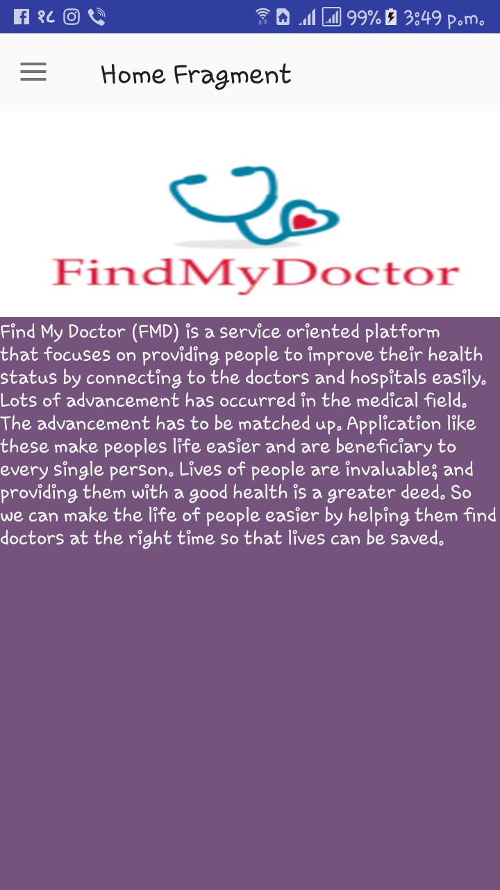

Code:
public class MainActivity extends AppCompatActivity {
Toolbar toolbar;
DrawerLayout drawerLayout;
NavigationView navigationView;
ActionBarDrawerToggle actionBarDrawerToggle;
FragmentTransaction transaction;
@Override
protected void onCreate(@Nullable Bundle savedInstanceState) {
super.onCreate(savedInstanceState);
setContentView(R.layout.material_design);
toolbar = (Toolbar) findViewById(R.id.toolbar);
drawerLayout = (DrawerLayout) findViewById(R.id.matdesign);
navigationView = (NavigationView) findViewById(R.id.navigationcontainer);
setSupportActionBar(toolbar);
actionBarDrawerToggle = new ActionBarDrawerToggle(this, drawerLayout, toolbar, R.string.draweropen, R.string.drawerclose);
drawerLayout.setDrawerListener(actionBarDrawerToggle);
transaction = getSupportFragmentManager().beginTransaction();
transaction.add(R.id.container, new HomeFragment());
getSupportActionBar().setTitle("Home Fragment");
transaction.commit();
navigationView.setNavigationItemSelectedListener(new NavigationView.OnNavigationItemSelectedListener() {
@Override
public boolean onNavigationItemSelected(@NonNull MenuItem item) {
switch (item.getItemId()) {
case R.id.drawer_home:
transaction = getSupportFragmentManager().beginTransaction();
transaction.replace(R.id.container, new HomeFragment());
getSupportActionBar().setTitle("Home fragment");
transaction.commit();
break;
case R.id.drawer_contact:
transaction = getSupportFragmentManager().beginTransaction();
transaction.replace(R.id.container, new Contact());
getSupportActionBar().setTitle("Contact");
transaction.commit();
break;
case R.id.drawer_doctor:
transaction = getSupportFragmentManager().beginTransaction();
transaction.replace(R.id.container, new doctor());
getSupportActionBar().setTitle("Doctors");
transaction.commit();
break;
case R.id.drawer_location:
transaction = getSupportFragmentManager().beginTransaction();
transaction.replace(R.id.container, new location());
getSupportActionBar().setTitle("Location");
transaction.commit();
}
drawerLayout.closeDrawers();
return false;
}

2.7.2 Integration Testing
Integration testing is defined as the testing of combined parts of an application to determine if they function correctly. Integration testing can be done in two ways: Bottom-up integration testing and Top-down integration testing. The different modules were integrated and tested to ensure that they work perfectly and address the objectives set in the initial phase of the system development.

Test case 1: Display the doctors requested by the user. Test data: Successfully entries doctors request form.
Expected Outcome: When the user successfully requests for the request is shown in the request interface so that the doctors can be found.
Evidence:
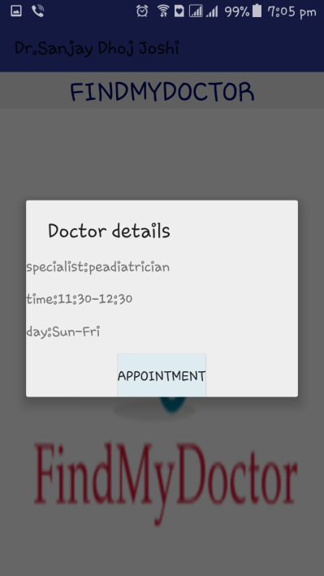

Test case 2: Display the calendar for appointments.
Test data: appointment calendar
Expected Outcome: When the user successfully requests for the request is shown in the request interface so that the doctors can be found, appointments being taken.
Evidence:
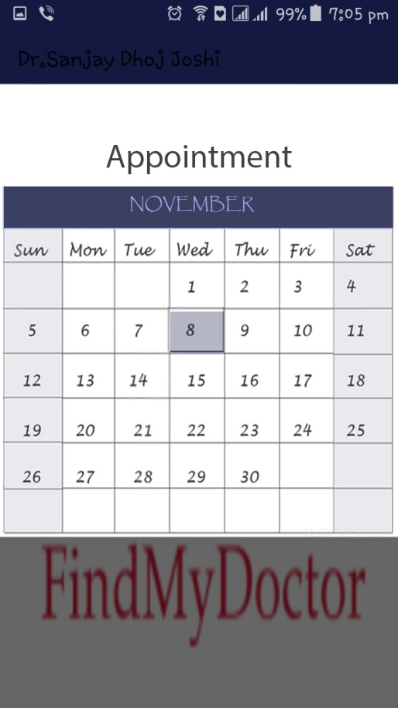

3.7.3 System Testing
System testing tests the system as a whole. Once all the components are integrated,
the application as a whole is tested rigorously to see that it meets the specified
Quality Standards. This type of testing is performed by a specialized testing team.
System testing is important because of the following reasons:
- System testing is the first step in the Software Development Life Cycle, where the application is tested as a whole.
- The application is tested thoroughly to verify that it meets the functional and
technical specifications.
- The application is tested in an environment that is very close to the production
environment where the application will be deployed.
- System testing enables us to test, verify, and validate both the business
requirements as well as the application architecture.

CHAPTER 3: DISCUSSION AND CONCLUSION

Critical Analysis

The project “Mobile Application for Health Assistance” was developed to help the users who are in search of doctors for different cases. In a developing country like Nepal where people choose to ignore or tolerate this problem, this application would provide a platform where people can request for the doctors with the use of mobile phones. The author hopes that after searching for the doctor, they would get the required information about the doctors and the hospitals.
During the research phase the author went through different papers and journal articles. The research was carried out extensively to get as more knowledge as possible. From the research, the author gathered that a lot of information and knowledge regarding the issue and the tools for the development of the app. From the research, the author concluded that doctors availability is an important issue in Nepal and information and communication can play a major role in bringing about a change.
From the research the author has found that the availability of mobile application in this field of finding the doctor is not available in Nepal. The applications are prominently seen in places like Pakistan and USA. This type of application has made it easier in these countries as it is very feasible , free and easily available.
As per the system, it was developed for mobile phones as mobile phones are more accessible to users than computers. Also, the use of smart phone is increasing. The worldwide Smartphone market is growing 13.0% year over year in 2015 Q2, according to data from the International Data Corporation (IDC) Worldwide Quarterly Mobile Phone Tracker. (IDC worldwide Mobile Tracker)The application was chosen to be developed in Android as it covers 70.85% of worldwide Smartphone OS share. (Worldwide Smartphone OS)Meanwhile 23.1% of it is occupied by iOS but iPhones are quite expensive so is not much in use in a developing country like Nepal. Developing for iOS would have its benefits as it doesn't have a multitude of devices and screen sizes. But the number of android phone users in Nepal is considerably higher than iPhone users so android platform was selected.
For Android app development Google currently supports two IDEs: Android Developer Tools (ADT) and Android Studio. The first option uses the well- established Eclipse IDE. The second option is based upon the IntelliJ IDE.
Comparing between android studio and eclipse, the author found that android studio uses gradle build system whereas Eclipse uses Apache Ant as its prime build system that is an extremely robust XML based build system. The author found that code completion is better on android studio as compared to Eclipse. Eclipse is simply Java based software and a larger IDE in comparison with Android Studio, so it needs considerably higher amount of RAM space with a high CPU speed to function properly.

Failure to meet this criterion causes Eclipse crashing and becoming unresponsive. On the other hand, Android Studio is now released with lesser bugs, and provides a more stable performance guarantee than Eclipse and the system requirements are lower too. Also, Google has announced that they are ending development and official support for the Android Developer Tools (ADT) in Eclipse by the end of the year 2016.
Hence, Android Studio, Google’s official IDE for Android was selected to develop the mobile application. The user interface was designed in XML. The authors wanted to enhance their knowledge in java. So, java programming platform was used to write the business logic.
Google Map API was used to embed map in application and Places API was used to get Auto complete service for getting location, and latitude and longitude values of the location.
From a developer’s perspective, author have tried to develop a platform with easy user interface and tried to keep it simple. The author has tried to do strong backend coding to uphold security risks and possible errors and bugs. Also, databases are managed in such way the required data will be generated fast. One of the limitations of the mobile application is that it requires internet access. The app cannot function without the internet. In a country like Nepal where fast and reliable internet access is not easily available, this could be one of the biggest challenges.

  - Limitations and Future Enhancement

    - Limitation:

      - There is a chance of false registration.
      - Even if anyone request for the doctors info the app is unable to guarantee whether the doctor is available or not.
      - Unable to run the app without the internet.
      - Unable to show Map and Route of the hospital.

    - Future enhancements:

1. Email address confirmation while registration of user.
2. Real time reporting system using GPS.
3. Addition information of more hospitals
4. Receiving notification.

CONCLUSION

The FMD application in android will get the basic information about all details of particular doctors, information about diseases and will show the path or location of the particular hospital.
So this app will help get instant online appointments. We can use it anywhere at any time which shows the online registration form and user can get appointment.
Find My Doctor (FMD) is a service oriented platform that focuses on providing people to improve their health status by connecting to the doctors and hospitals easily. Lots of advancement has occurred in the medical field. The advancement has to be matched up. Application like these make peoples life easier and are beneficiary to every single person. Lives of people are invaluable; and providing them with a good health is a greater deed. So we can make the life of people easier by helping them find doctors at the right time so that lives can be saved.
The proposed system facilitates communication between patients, doctors and hospitals and integrates the information about doctors in different hospitals in the city. Public will be able to use the FMD as an application installed on their smartphones to help them find doctors with minimal effort and time.
Analyzing the current scenario, FMD aims to be a great benefit to every single person to be easily connected to the hospitals in the city. It also carries the potential to bring a breakthrough in the hospital service which ultimately is connected with human lives. Making impact on the community and digitizing a developing country like ours with the help of a field that no one stays away from helps the country to take a big leap in the use of IT in this technological era.
Since, there are hardly any mobile applications for the hospitals in Nepal , this application turns out to be very useful in various ways as per the aspect of the users.

Bibliography
tutsplus. (2011). Retrieved from http://code.tutsplus.com/tutorials/learn-java-for-android-development- introduction-to-java--mobile-2604.: http://code.tutsplus.com
Business Dictinonary. (2013). Retrieved 2017, from http://www.businessdictionary.com/definition/feasibility-study.html: http://www.businessdictionary.com/definition/feasibility-study.html
nbdc.unomaha.edu. (2014). Retrieved 2017, from http://nbdc.unomaha.edu/technology- commercialization/techventure/model.cfm?title=TechVenture_Technical_ Feasibility. : http://nbdc.unomaha.edu/technology- commercialization/techventure/model.cfm?title=TechVenture_Technical_ Feasibility.
androidhive. (2014, 05). Retrieved 2017, from http://www.androidhive.info/2014/05/android-working-with-volley- library-1.: http://www.androidhive.info
Cloud based Platform. (2014). Retrieved 2017, from http://www.predix.com/blog/cloud-based-platforms-hold-key- healthcare-innovation. : http://www.predix.com
reference.business-finance. (2014). Retrieved 2017, from http://www.reference.com/business-finance/operational-feasibility- 300ab6b96428cf68.: http://www.reference.com/business-finance/operational-feasibility.
Android. (2015). Retrieved 2017, from www.mit.edu/afs.new/sipb/project/android/docs/about/index.html.: www.mit.edu/afs.new/sipb/project/android/docs/about/index.html.
support.office. (2016). Retrieved from https://support.office.com/enus/article/Basic-tasks-in-Word-2016- 87b3243c-b0bf-4a29-82aa-09a681999fdc, 2016,.: https://support.office.com
Android. (n.d.). Retrieved 2017, from http://android- arsenal.com/details/1/362. : http://android- arsenal.com/
Chung, C.-C. (2011, 12 1). https://www.researchgate.net/.../254018067_Bluetooth-Based_Android_Interactive_App... Retrieved 2017, from https://www.researchgate.net/.../254018067_Bluetooth-Based_Android_Interactive_App...: https://www.researchgate.net
cloud messaging. (n.d.). Retrieved 2017, from https://firebase.google.com/docs/cloud-messaging: https://firebase.google.com
D.Modi, J. a. (2016, 6). https://www.ijircce.com/upload/2016/june/107_Remote.pdf. Retrieved 2017, from https://www.ijircce.com/upload/2016/june/107_Remote.pdf: https://www.ijircce.com
Fragment API. (n.d.). Retrieved 2017, from https://developer.android.com/guide/components/fragments.html.: https://developer.android.com/guide/components/fragments.html.
IDC worldwide Mobile Tracker. (n.d.). Retrieved 2017, from http://www.idc.com/prodesrv/smartphone-os-market-share.jsp: http://www.idc.com
Katti, S. a. (2012). https://www.ijitee.org/download/volume-3-issue-3/. Retrieved 2017, from https://www.ijitee.org/download/volume-3-issue-3/: https://www.ijitee.org
M.W. Munir, S. O. (2015). https://www.researchgate.net/.../276927630_An_Android_based_Application_for_De... Retrieved 2017, from https://www.researchgate.net/.../276927630_An_Android_based_Application_for_De...: https://www.researchgate.net
MahatmaGandhi. (n.d.). https://www.brainyquote.com/quotes/quotes/m/mahatmagan134936.html. Retrieved 10 11, 2017, from www.brainyquote.com: https://www.brainyquote.com/quotes/quotes/m/mahatmagan134936.html
MAPS. (n.d.). Retrieved from https://play.google.com/store/apps/details?id=com.google.androidapps.ma ps.: https://play.google.com
Mendelson, E. (2016). tech redar.
Merriam. (n.d.). Retrieved 2017, from http://www.merriam- webster.com/dictionary/flowchart. : http://www.merriam- webster.com/dictionary/flowchart.
Open handset alliance. (n.d.). Retrieved 2017, from http://www.openhandsetalliance.com.: http://www.openhandsetalliance.com.
openhandsetalliance. (n.d.). Retrieved 2017, from http://www.openhandsetalliance.com.: http://www.openhandsetalliance.com.
P.Beck. (2014). IOWA state university. Retrieved 2017, from https://www.extension.iastate.edu/agdm/wholefarm/html/c5- 65.html.: https://www.extension.iastate.edu
P.Doshi, P. J. (2014). International journal of engineering and computer science. Retrieved 2017, from esatjournals.net/ijret/2015v04/i05/IJRET20150405083.pdf: esatjournals.net/ijret/2015v04/i05/IJRET20150405083.pdf
Project management Institute. (n.d.). Retrieved 2017, from http://www.pmi.org/About-Us/About-Us-What-is- Project-Management.aspx.: http://www.pmi.org
Sharma, R. (2011, 05 27). www.brighthubpm.com. Retrieved 2017, from http://www.brighthubpm.com/project-planning/99511-methods-of-data-collection-in-stakeholder-analysis/: http://www.brighthubpm.com/project-planning/99511-methods-of-data-collection-in-stakeholder-analysis/
Spat S. et al. (2012) A Mobile Android-Based Application for In-hospital Glucose Management in Compliance with the Medical Device Directive for Software. In: Nikita K.S., L. J. (n.d.). springer. Retrieved from https://link.springer.com/chapter/10.1007%2F978-3-642-29734-2_29: https://link.springer.com
Springer, B. H. (2011). springer. Retrieved 2017, from https://link.springer.com/chapter/10.1007%2F978-3-642-29734-2_29: https://link.springer.com
stakeholder. (n.d.). http://www.brighthubpm.com/project-planning/99511-methods-of-data- collection-in-stakeholder-analysis/. Retrieved 10 11, 2017, from www.brighthubpm.com: http://www.brighthubpm.com/project-planning/99511-methods-of-data- collection-in-stakeholder-analysis/.
Sybase. (n.d.). Retrieved 2017, from http://infocenter/sybase.com/help/topic/com.sybase.infocenter.dc38088165 0/doc/html/rad1232026266129.html.: http://infocenter/sybase.com/help/topic/com.
tutorialspoint. (n.d.). Retrieved 2017, from http://www.tutorialspoint.com/android/android_json_parser.htm.: http://www.tutorialspoint.com
Tzeng, W.-G. (2015). ir.nctu.edu.tw. Retrieved 2017, from https://ir.nctu.edu.tw/handle/11536/45942: https://ir.nctu.edu.tw/handle/11536/45942
Worldwide Smartphone OS. (n.d.). Retrieved 2017, from https://www.netmarketshare.com/operating-system-market-share-: https://www.netmarketshare.com

